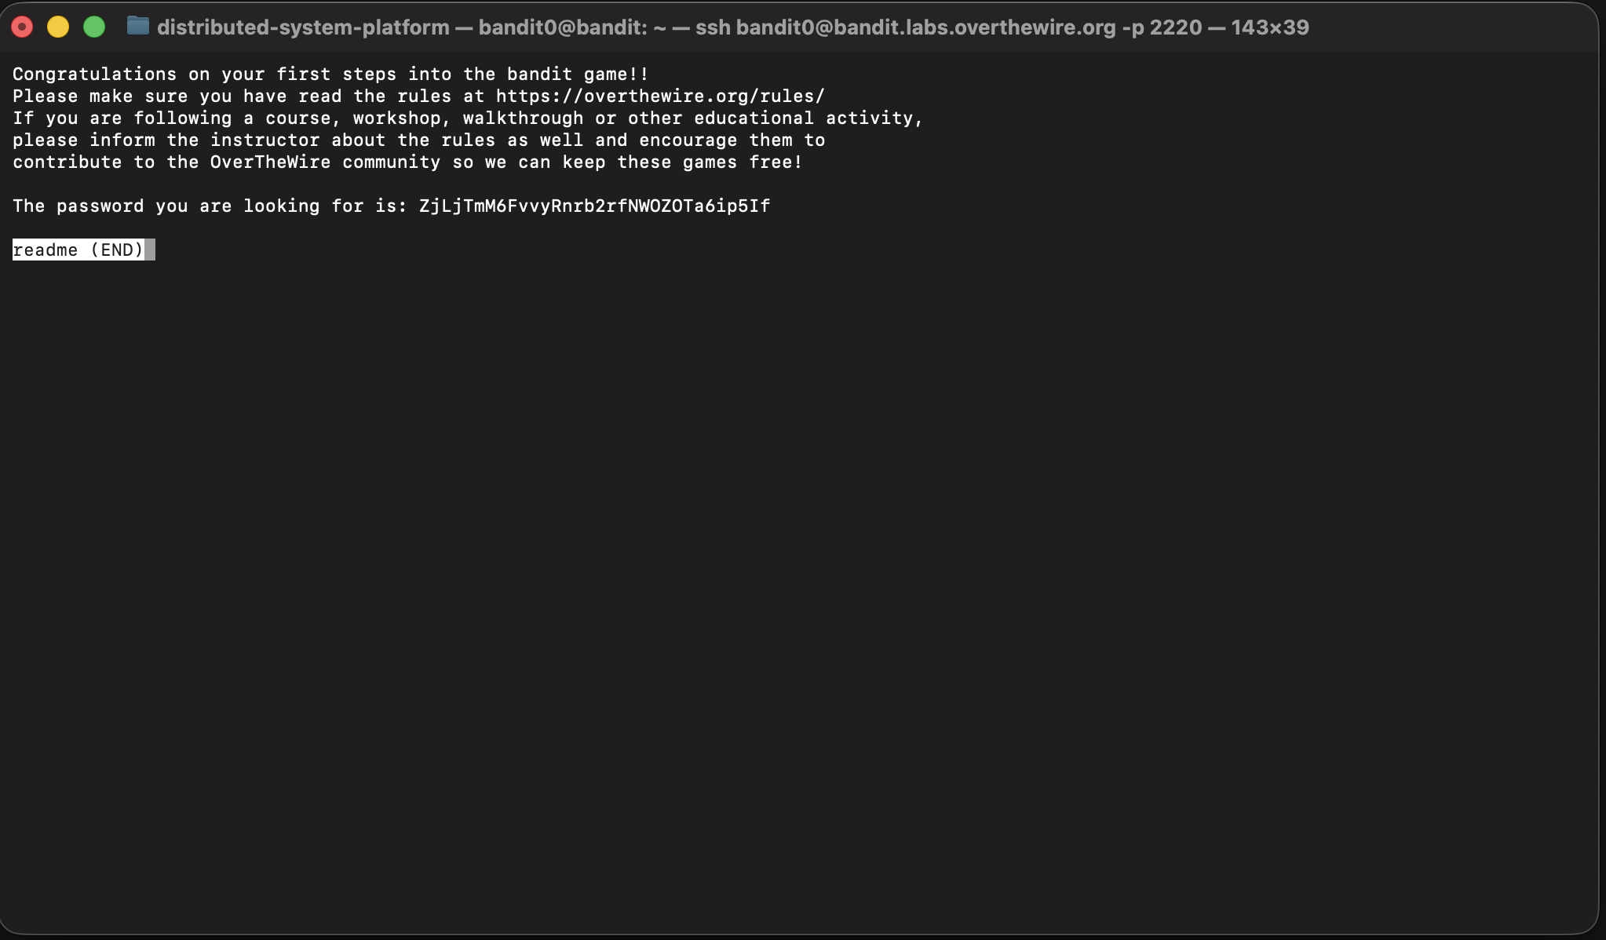

Пароль на следующий уровень ZjLjTmM6FvvyRnrb2rfNWOZOTa6ip5If

Bandit1

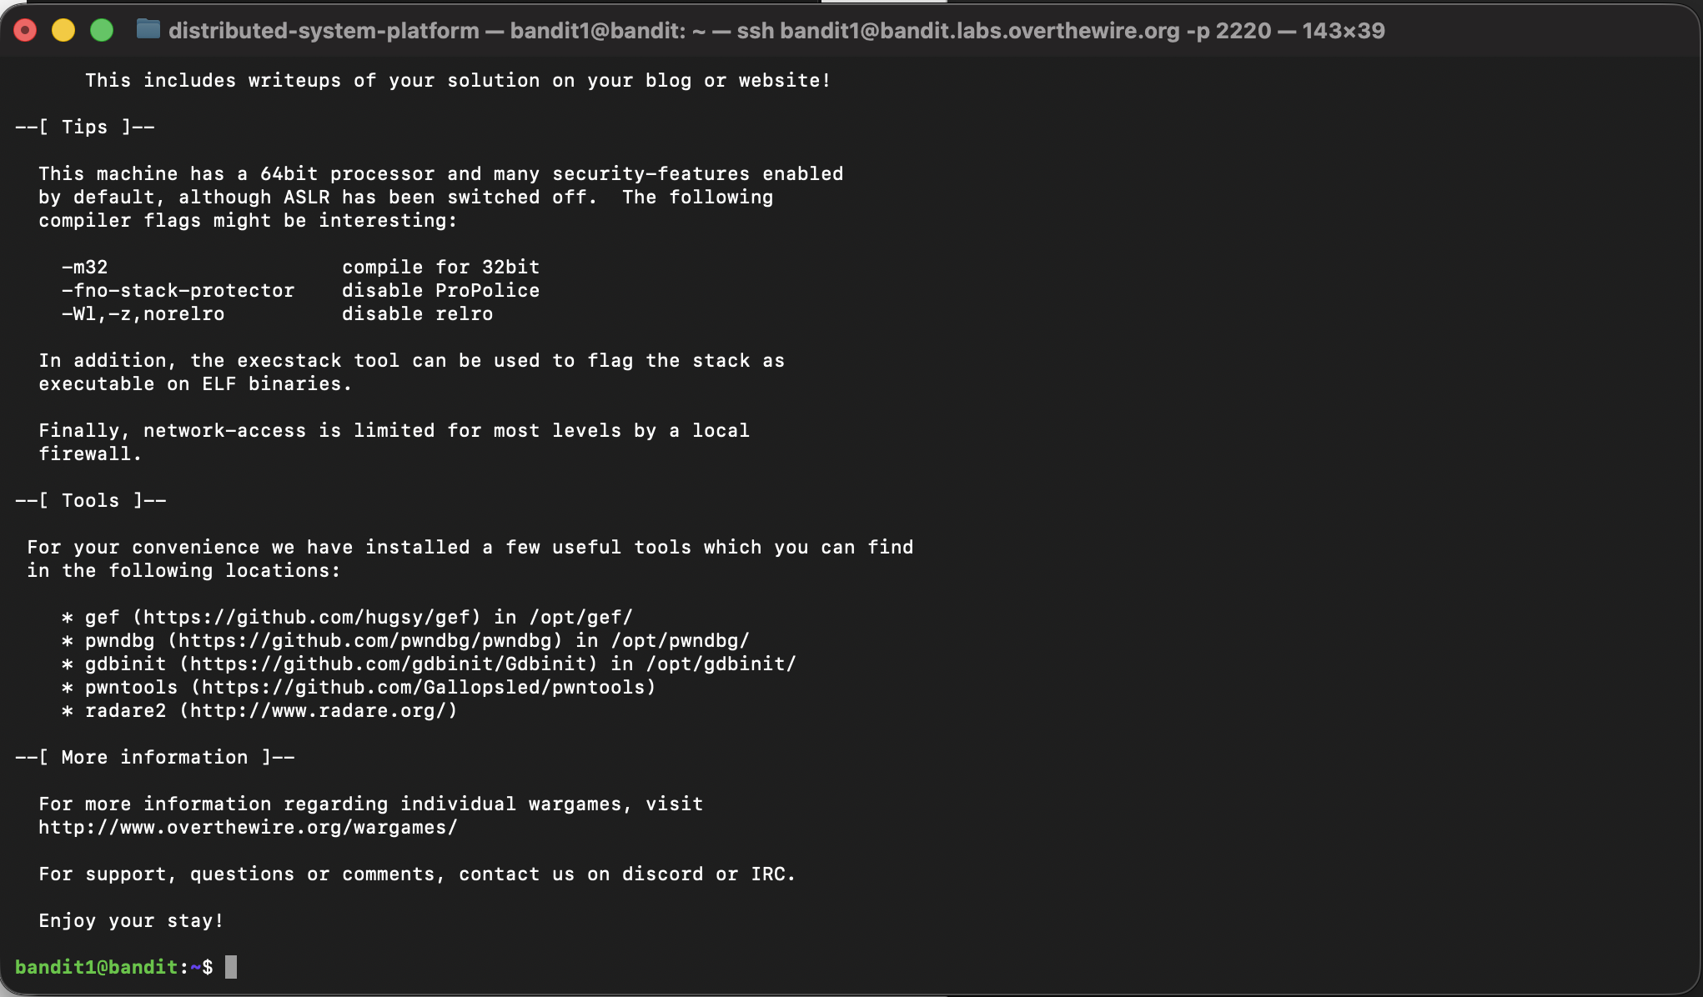

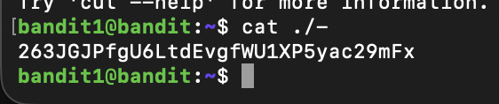

263JGJPfgU6LtdEvgfWU1XP5yac29mFx

Bandit2

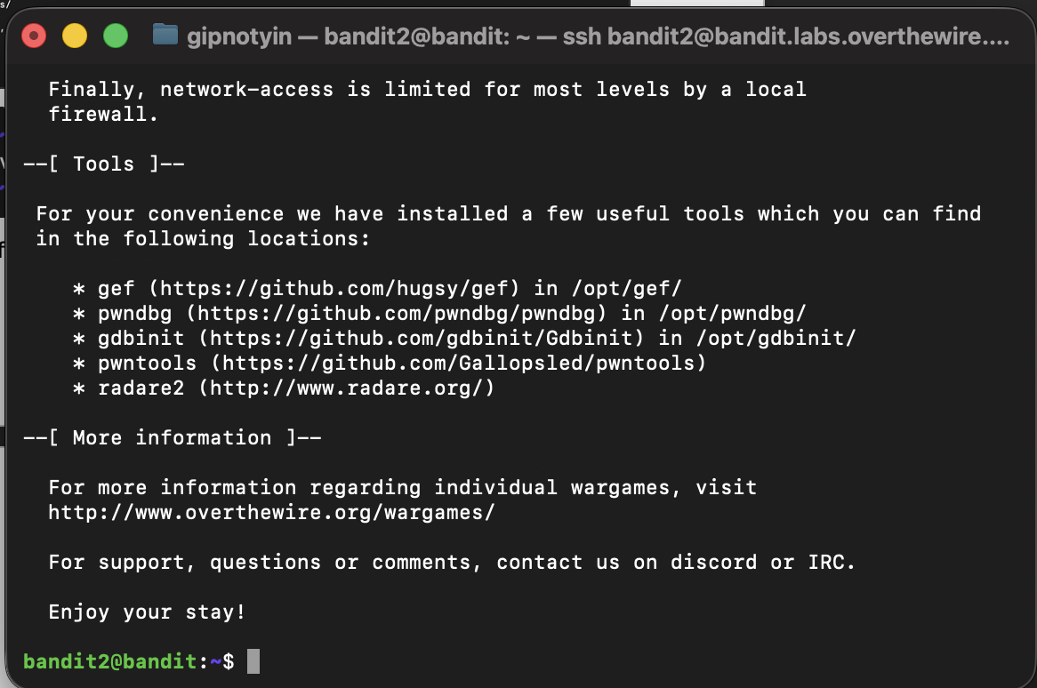

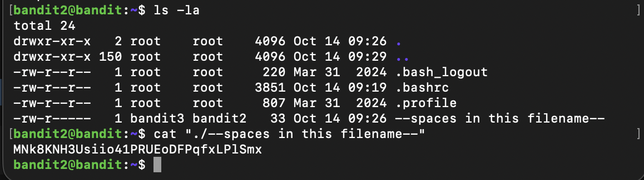

MNk8KNH3Usiio41PRUEoDFPqfxLPlSmx

Bandit3

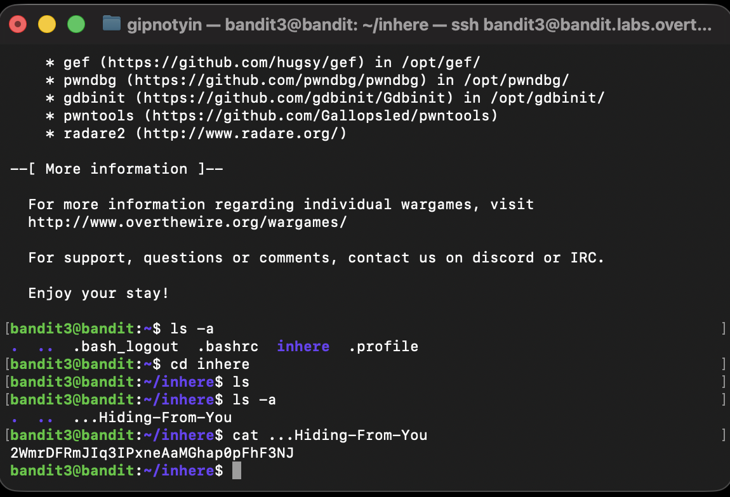

2WmrDFRmJIq3IPxneAaMGhap0pFhF3NJ

Bandit4

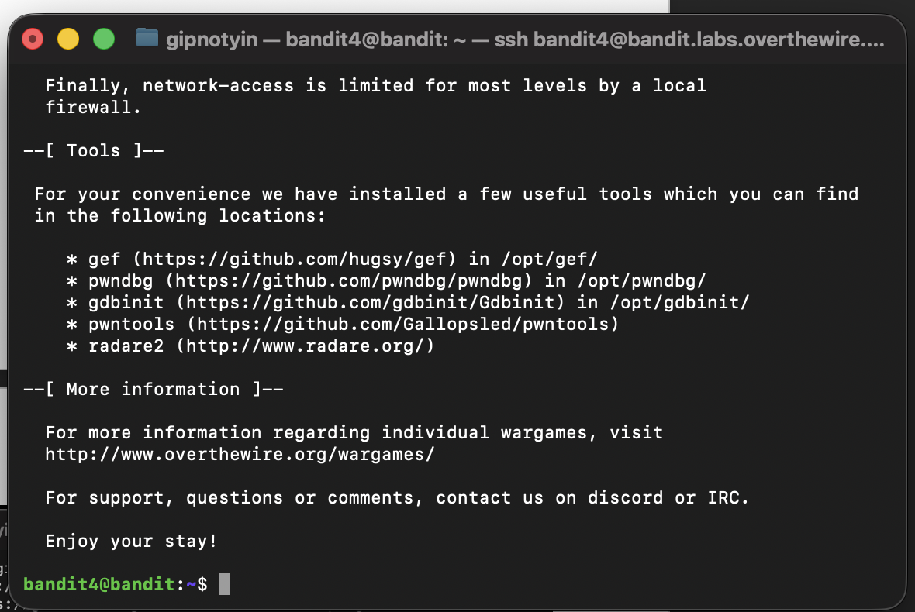

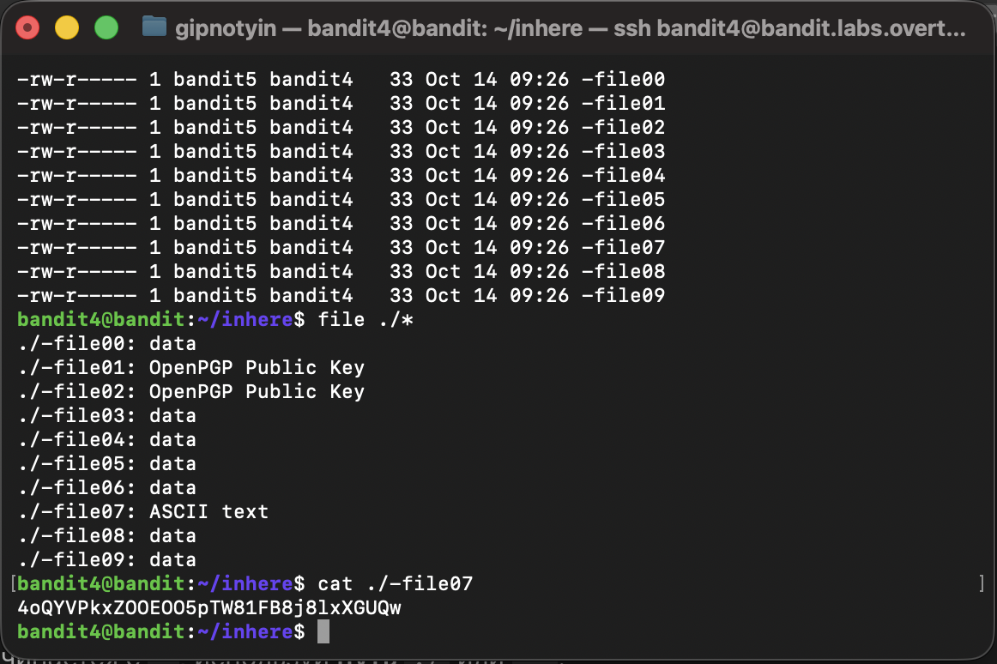

4oQYVPkxZOOEOO5pTW81FB8j8lxXGUQw

Bandit5

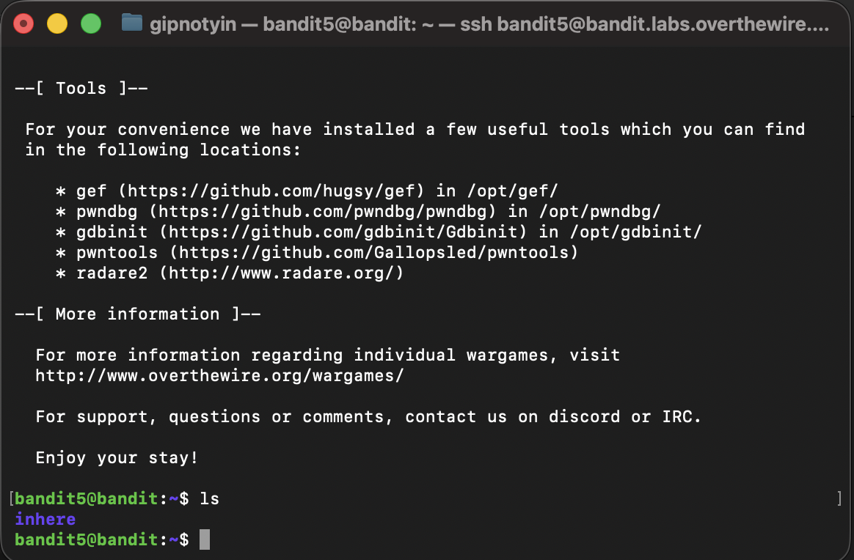

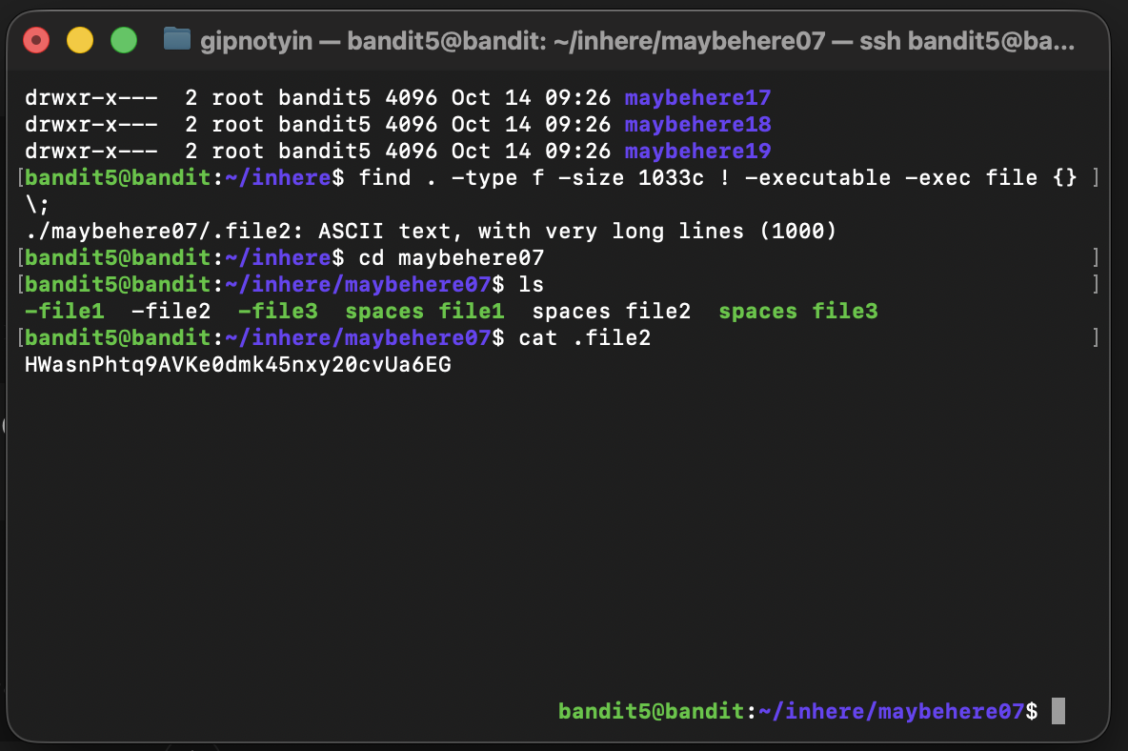

HWasnPhtq9AVKe0dmk45nxy20cvUa6EG

Bandit6

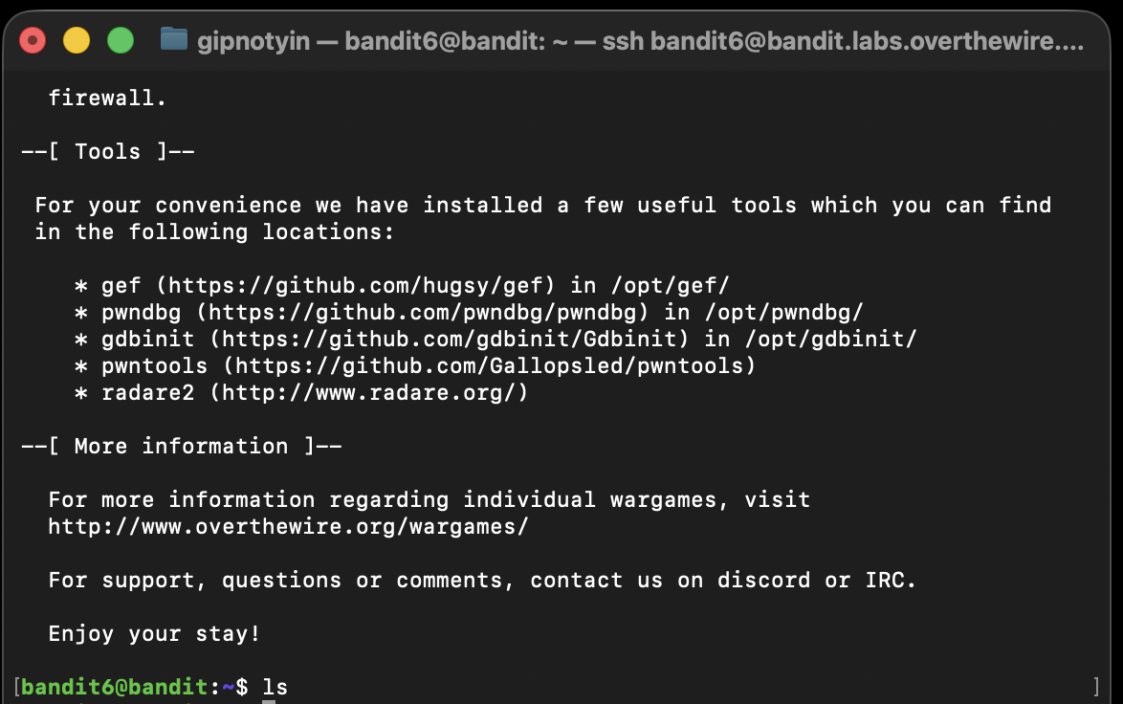

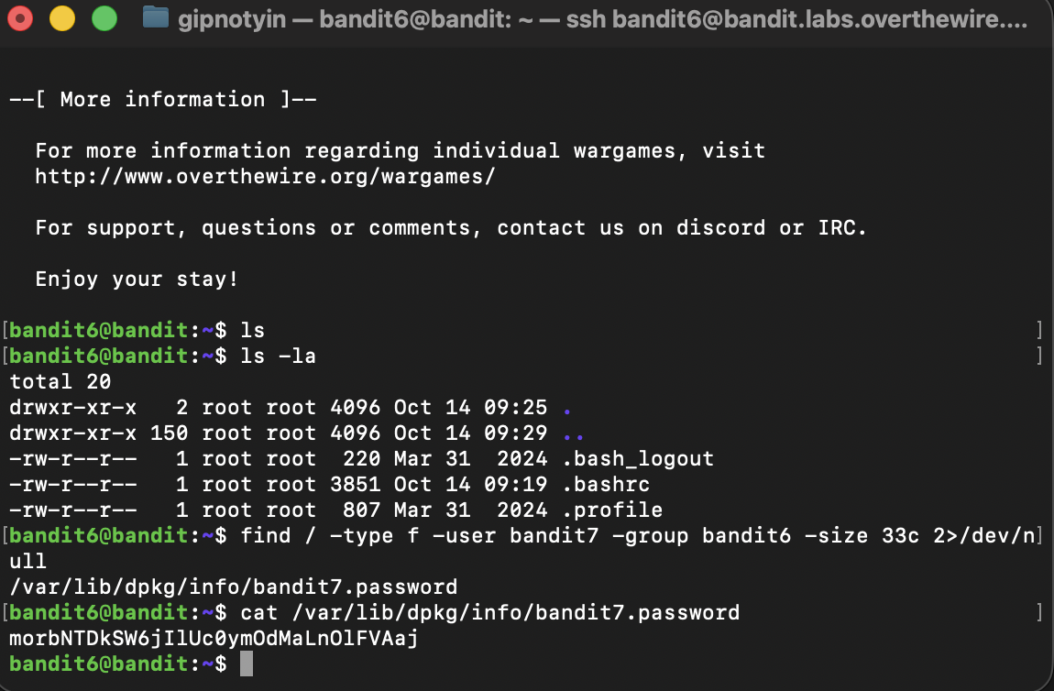

morbNTDkSW6jIlUc0ymOdMaLnOlFVAaj